ALLAMA IQBAL OPEN UNIVERSITY, ISLAMABAD
Department of Computer Science

Submitted by: Tayyaba Shakoor (0000674807)
Amara Kausar (0000675295)
Alleezza Tasaddaq (0000674844)

Course Tittle: Database LAB
Course Code: 6907
Semester: 4th
Section: A
Project: Grocery_Store
Instructor Name: Ms. Samreen Akhtar

Project Overview:
- A web-based application for managing grocery store products.
- Built using Python (Flask) for backend, SQL Server for database, and HTML/CSS for frontend.
- Main features:
- Add new products.
- Delete existing products.
- View all products with their categories.

Technology Stack:
Layer | Technology
Backend | Python Flask
Database | SQL Server
Frontend | HTML, CSS, Jinja2

Database Design:
Tables:
- categories
- category_id → Primary Key, Auto-increment
- category_name → Name of category (e.g., Fruits, Vegetables, Dairy, Snacks)
- products
  - product_id → Primary Key, Auto-increment
  - product_name → Name of product
  - category_id → Foreign Key linking to categories
  - price → Product price
  - quantity → Available stock
  - created_at → Timestamp of when product was added
SQL Code Overview:
Database:
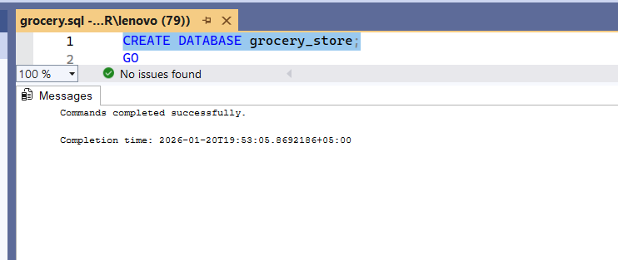
Use of Database:
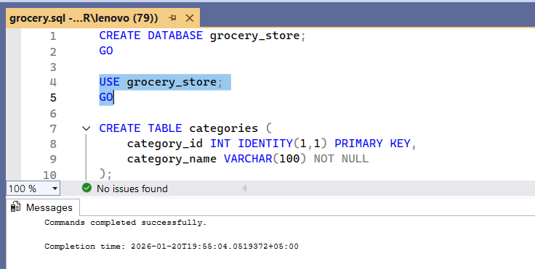
Create Table:
  - Categories Table:

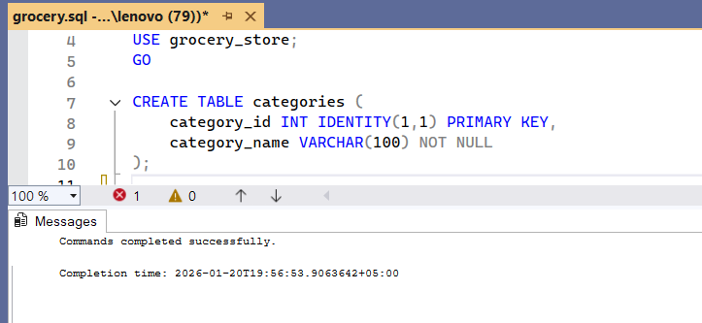

  - Products Table:

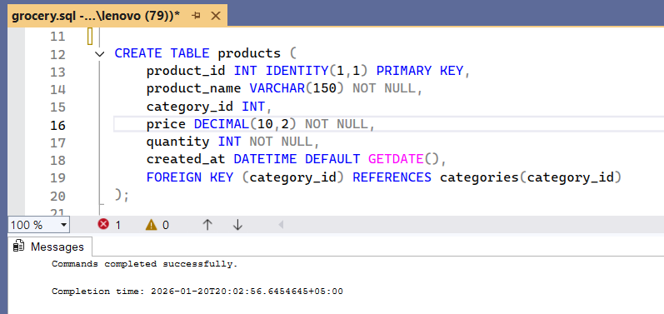
Insert Values into Tables:

- Categories:

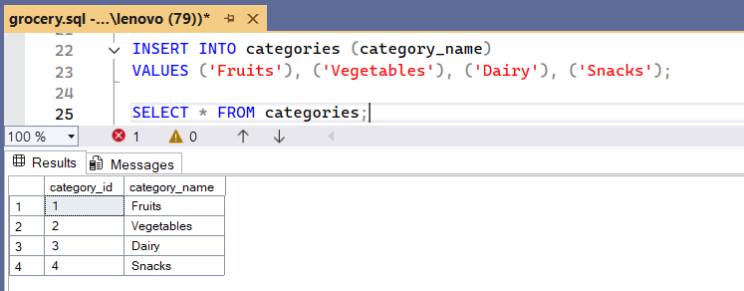

- Products:

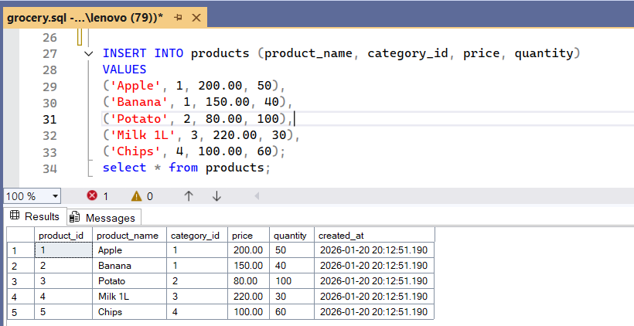

Frontend Codes:
- Html Code:
<!DOCTYPE html>
<html>
<head>
<title>Grocery Store</title>
<style>
body { font-family: Arial; padding: 20px; }
table { border-collapse: collapse; width: 100%; }
th, td { border: 1px solid #ccc; padding: 8px; text-align: center; }
th { background: #f4f4f4; }
form { margin-bottom: 20px; }
input, select, button { padding: 6px; }
</style>
</head>
<body>

<h2>Add Product</h2>
<form method="POST" action="/add">
<input type="text" name="name" placeholder="Product Name" required>

<select name="category" required>
{% for c in categories %}
<option value="{{ c.category_id }}">{{ c.category_name }}</option>
{% endfor %}
</select>

<input type="number" name="price" placeholder="Price" required>
<input type="number" name="quantity" placeholder="Quantity" required>

<button type="submit">Add Product</button>
</form>

<hr>

<h2>Product List</h2>
<table>
<tr>
<th>ID</th>
<th>Name</th>
<th>Category</th>
<th>Price</th>
<th>Quantity</th>
<th>Action</th>
</tr>

{% for p in products %}
<tr>
<td>{{ p.product_id }}</td>
<td>{{ p.product_name }}</td>
<td>{{ p.category_name }}</td>
<td>{{ p.price }}</td>
<td>{{ p.quantity }}</td>
<td>
<a href="/delete/{{ p.product_id }}">Delete</a>
</td>
</tr>
{% endfor %}
</table>

</body>
</html>

- Style.CSS:

* {
margin: 0;
padding: 0;
box-sizing: border-box;
font-family: Arial, Helvetica, sans-serif;
}

body {
background-color: #f4f6f8;
padding: 30px;
}

/* Page Title */
h1, h2 {
text-align: center;
margin-bottom: 20px;
color: #333;
}

/* Form Styling */
form {
background: #ffffff;
padding: 20px;
max-width: 700px;
margin: 0 auto 30px;
border-radius: 8px;
box-shadow: 0 2px 8px rgba(0,0,0,0.1);
}

form input,
form select {
width: 100%;
padding: 10px;
margin-bottom: 12px;
border: 1px solid #ccc;
border-radius: 5px;
}

form button {
background-color: #2ecc71;
color: #fff;
border: none;
padding: 12px;
width: 100%;
font-size: 16px;
border-radius: 5px;
cursor: pointer;
}

form button:hover {
background-color: #27ae60;
}

/* Table Styling */
table {
width: 100%;
border-collapse: collapse;
background: #ffffff;
box-shadow: 0 2px 8px rgba(0,0,0,0.1);
}

table th {
background-color: #3498db;
color: white;
padding: 12px;
}

table td {
padding: 10px;
text-align: center;
border-bottom: 1px solid #ddd;
}

table tr:hover {
background-color: #f1f1f1;
}

/* Delete Button */
a.delete-btn {
color: white;
background-color: #e74c3c;
padding: 6px 10px;
text-decoration: none;
border-radius: 4px;
}

a.delete-btn:hover {
background-color: #c0392b;
}

/* Responsive */
@media (max-width: 768px) {
table, thead, tbody, th, td, tr {
display: block;
}

table tr {
margin-bottom: 15px;
}

table td {
text-align: right;
padding-left: 50%;
position: relative;
}

table td::before {
content: attr(data-label);
position: absolute;
left: 10px;
width: 45%;
padding-left: 10px;
font-weight: bold;
text-align: left;
}
}

- Script.js:

document.addEventListener("DOMContentLoaded", function () {

const deleteButtons = document.querySelectorAll(".delete-btn");

deleteButtons.forEach(function (btn) {
btn.addEventListener("click", function (event) {
if (!confirm("Are you sure you want to delete this product?")) {
event.preventDefault();
}
});
});

const form = document.querySelector("form");

form.addEventListener("submit", function (event) {
const price = document.querySelector("input[name='price']").value;
const quantity = document.querySelector("input[name='quantity']").value;

if (price <= 0 || quantity <= 0) {
alert("Price & Quantity must be greater than zero");
event.preventDefault();
}
});
});

Output:
